**REPORT**

**System implementation, testing and validation report for**

**SMART HOME SYSTEM**

|  |  |
| --- | --- |
| Document No: | 2 |
| Prepared by: | BSE 20-43 |
| Date: | 14/10/2020 |
| Version: | 1.2 |

**DOCUMENT APPROVAL**

|  |  |  |  |
| --- | --- | --- | --- |
| **Name** | **Role** | **Date** | **Signature** |
| Thakkar Brinda Sanjaykumar | Author(s) |  |  |
| Waiswa Brian Victor | Validation |  |  |
|  | Client |  |  |

Table of Contents

CHAPTER 1: INTRODUCTION 22

1.1 BACKGROUND AND SCOPE OF THE PROJECT 22

1.1.1 BACKGROUND 22

1.1.2 SCOPE 22

1.2 OVERVIEW OF THE DOCUMENT 22

2. SYSTEM SPECIFICATIONS 23

2.1 VERSION OF REQUIREMENTS AND VERSION CONTROL 23

2.2 INPUT 23

2.3 OUTPUT 24

2.4 FUNCTIONALITY 25

2.5 LIMITATIONS AND SAFETY 25

2.5.1 LIMITATIONS 25

2.5.2 SAFETY 25

2.6 DEFAULT SETTINGS 26

2.7 SPECIAL REQUIREMENTS 26

2.8 ERRORS AND ALARMS 26

*C*HAPTER 3: DESIGN OUTPUT 27

3.1 IMPLEMENTATION (CODING AND COMPILATION) 27

3.2 VALIDATION AND TESTING 27

3.3 INACTIVE CODE 27

3.4 DOCUMENTATION 28

CHAPTER 4: INSPECTION AND TESTING 29

4.1 INTRODUCTION 29

4.2 TEST PLAN AND PERFORMANCE 30

4.2.1 TEST OBJECTIVES 30

4.2.2 SCOPE AND RELEVANCY OF TESTS 30

4.2.3 LEVELS OF TESTS 31

4.2.4 TYPES OF TESTS 31

4.2.5 SEQUENCE OF TESTS 32

4.3 PRECAUTIONS 33

4.3.1 ANOMALOUS CONDITIONS 33

4.3.2 PRECAUTIONARY STEPS TAKEN 33

CHAPTER 5: INSTALLATION AND SYSTEM ACCEPTANCE TEST 34

5.1 INPUT FILES 34

5.2 SUPPLEMENTARY FILES 34

5.3 INSTALLATION QUALIFICATION 34

CHAPTER 6:PERFORMANCE,SERVICING, MAINTENANCE, AND PHASE OUT 36

6.1 SERVICE AND MAINTENANCE 36

6.2 PERFORMANCE AND MAINTENANCE 36

CHAPTER 7: CONCLUSION AND RECOMMENDATIONS 38

7.1 CONCLUSION 38

7.2 RECOMMENDATION 38

APPENDIX A: USER MANUAL 40

LOGIN SCREEN 41

CONTROLS SCREEN 42

STATUS SCREEN 43

**LIST OF FIGURES**

Figure 8.1 Smart Home System 40

Figure 8.2 Login Screen 41

Figure 8.3 Control Screen 42

Figure 8.4 Status Screen 43

**LIST OF TABLES**

Table 3.1 Design details 28

Table 4.1 Inspection plan and performance 29

Table 5.1 Checklist of the Installation and system acceptance test 34

Table 5.2 Installation Procedure Check 35

Table 6.1 Performance and maintenance details 37

# CHAPTER 1: INTRODUCTION

## BACKGROUND AND SCOPE OF THE PROJECT

### BACKGROUND

A smart home refers to a home equipped with a communication network, high-tech household devices, appliances and sensors that can be remotely accessed, monitored and controlled and can provide services responding to the user’s needs.

### SCOPE

This project aims at designing a prototype for monitoring and controlling of the different home appliances like lights, fans, doors, alarms. This will be controlled wirelessly via an android mobile application.

This system is aimed to be used in homes to control the home appliances. It will be controlled wirelessly using Wi-Fi.

The system consists of different sensors and Arduino UNO through which the mobile application can get the status of the appliances.

## OVERVIEW OF THE DOCUMENT

This document describes the implementation, testing and validation findings for the xxx system. It is divided into the following sections:

**Section 1**: This section gives an overview of the document

**Section 2**: this section describes and specifies the system completely and is the basis of the validation process

**Section 3**: the design details of the system

**Section 4**: this section involves testing which is in compliance with the requirements, the system test specification, complexity, risks and intended use of the system.

**Section 5**: this section describes process of the components of the system.

**Section 6**: this section describes the services, maintenance, performance, and the solutions for the system

**Section 7**: this section gives the conclusion of the whole project and the recommendation as well

**Section 8**: this section has the user manual for the system

# 2. SYSTEM SPECIFICATIONS

## 

## 2.1 VERSION OF REQUIREMENTS AND VERSION CONTROL

The final version for the requirements specification which was used in the system development was 1.2. We made changes in the product functions and the software quality attributes in version 1.

Changes were made to all the product functions as it was very brief, so we had to describe all the functions in details for better understanding. Some changes were also made to the software quality attributes as we had missed out on few attributes. So we added the missing attributes.

We used GITHUB for version control for the coding of our system.

## 2.2 INPUT

The inputs for the Smart Home System are:

*Input 1*: the temperature is received from the temperature sensor.

When the temperature sensor senses the room temperature it sends the temperature reading to the Arduino and the mobile application. The temperature is captured in degree Celsius.

*Input 2*: the status of the light is received from the light sensor.

When the light sensor detects light or darkness it sends the signal to the system. The light sensor sends the readings to the Arduino and the mobile application. At the bright light, the ldr sends low value which less or equal to 900 and when there is darkness, the ldr sends value higher than 900.

*Input 3*: the status of the smoke in the house is received from the smoke sensor

The smoke sensor detects the smoke in the house. The smoke sensor sends integer value to the system. When the value is greater than 100, the smoke is detected and it sends the signal to the system.

*Input 4*: the status of the motion in the house is received from the motion sensor

The motion sensor detects the movement in the house. It sends information to the system of whether the motion is detected or not and it is sent in form of High or Low values.

*Input 5*: the commands are received from the mobile application

The mobile application sends different commands to the system when triggered by the user. These commands are for controlling the home appliances for turning it on or off. The commands are in form of text.

## 2.3 OUTPUT

*Output 1: The temperature reading*

The temperature reading is sent to the mobile application in form of text to display the temperature for the user.

*Output 2: The light status*

The system sends the light status to the mobile application in form of text and it also controls the turning on or off of the lights according to the brightness or darkness.

*Output 3: The smoke status*

The system triggers the buzzer if the smoke is detected. The status of the smoke in the house is displayed on the mobile application.

*Output 4: The motion status*

The system triggers the buzzer when the motion is detected in the house. The status of the motion in the house is displayed on the mobile application.

*Output 5: The fan status*

The fan is turned on or off according to the temperature received by the system and the fan status in form of text is sent to the mobile application.

*Output 6: Commands*

The system sends commands to the home appliances based on the information received from the sensors and the mobile application.

## 

## 2.4 FUNCTIONALITY

1. The system detects motion in the house and alerts the user about an intruder by triggering an alarm.
2. The system measures the room temperature and if the temperature is high, the system turns on the fan. If the temperature is very low, the system turns off the fan. It also allows the user to control the fan from the mobile application.
3. The system triggers the alarm if there is a fire outbreak in the house and if there is an intruder in the house.
4. The system detects smoke in the house and alerts the user about the smoke or fire outbreak in the house by triggering the alarm.
5. The system sends the status report of each home appliances to the user on the mobile application.

## 2.5 LIMITATIONS AND SAFETY

### 2.5.1 LIMITATIONS

1. The user has to be connected to the Internet connection in order to use the Smart home application to control the home appliances.
2. The system has power limitations, if there is no power the system cannot work as it’s an embedded system.
3. The system works only on smartphones which have Android OS.

### 2.5.2 SAFETY

The user should be careful about the live current and voltage of the components to prevent the system from getting damaged.

## 2.6 DEFAULT SETTINGS

1. By default the system is automatic, it runs on based on the commands triggered by the sensors sent to the system. Unless the user uses the mobile application to control the system.
2. By default there will be only two users which will be set by the administrator and the passwords and the users can be changed by the admin only.
3. By default the system is connected to the Wi-Fi for the controlling and monitoring of the home appliances from the mobile application.

## 2.7 SPECIAL REQUIREMENTS

To ensure security of the system, the mobile application has usernames and passwords.

## 2.8 ERRORS AND ALARMS

There can be errors in the readings of the temperature from temperature sensor, but it can be handled by refreshing the status in the mobile application.

# *C*HAPTER 3: DESIGN OUTPUT

## 3.1 IMPLEMENTATION (CODING AND COMPILATION)

For the implementation of the system we used the following tools, softwares, hardwares and environments;

***Proteus***: This was the main tool used for simulating embedded part of the system. This simulation was done before the actual implementation.

***Android Studio***: This was the IDE used to develop the Android mobile application.

***Arduino IDE***: This was used to write the code for the Arduino UNO to run the system

***Fritzing***: This was used to plan the connections of the system

***Wifi Module***: This was used to allow communication between the android phone and the embedded system

***Sensors***: Different sensors were used for the monitoring and controlling of the home appliances.

## 3.2 VALIDATION AND TESTING

***Proteus***: Was used to test the simulation of the embedded devices.

**Android smartphone**: Was used to test the mobile application to ensure communication with the embedded system and as well to ensure all the functions of the application are working the way they should.

## 3.3 INACTIVE CODE

The inactive code in our system are the comments which are used to explain the code and the program.

## 3.4 DOCUMENTATION

The documentation for the design of the system was the Software Design Document to help the software developers and other technical users of the system to understand how the system was built. It also provides detailed information of the system. The intended audiences are the system developers, testers, interface designers and project manager.

Table 3.1 Design details

|  |  |  |
| --- | --- | --- |
|  | | |
| *Topics* | **Design output** | |
| **Good programming practice** | Source code is... | Source code contains... |
| **Windows programming** |  | |
| **Dynamic testing** |  | |

# CHAPTER 4: INSPECTION AND TESTING

## 4.1 INTRODUCTION

The inspection and testing of the computer system was planned and documented in a test plan. The ex­tent of the testing is in compli­ance with the requirements, the system acceptance test specification, the approach, complexity, risks, and the in­tended and expected use of the computer system.

Table 4.1 Inspection plan and performance

| *Topics* | **3.3.1 Inspection plan and performance** | *Date / Initials* |
| --- | --- | --- |
| **Design output** |  | 15/08/2020  W.V |
| **Documentation** |  | 17/09/2020  B.T |
| **Software development environment** |  | 28/09/2020  W.V |
| **Result of inspection** |  | 1/10/2020  B.T |

## 4.2 TEST PLAN AND PERFORMANCE

|  |
| --- |
| The test plan was created during the development or reverse engineering phase and identify all elements that are about to be tested. The test plan should explicitly describe what to test, what to expect, and how to do the testing. Subse­quently it should be confirmed what was done, what was the result, and if the result was approved. 4.2.1 TEST OBJECTIVES  1. To test the communication between the Smart Home Application and the Arduino UNO. 2. To test the user click events from the smart phone. 3. To test the status of the home appliances on the Smart Home Application. 4. To test the login of the user from the Mobile application 5. To test the validity of the values sent from the sensors. 6. To test if the home appliances can be controlled from the Mobile application. 7. To test the Wi-Fi connection to the Arduino UNO via Wi-Fi module. |
| 4.2.2 SCOPE AND RELEVANCY OF TESTS  * To test the communication between the Smart Home Mobile Application and the Arduino UNO. * To detect the user click events from the smart phone. * To test the status of the home appliances on the Smart Home Application. * To test the validity of the values sent from the sensors to the Arduino UNO. * To test if the home appliances can be controlled from the mobile application.   The testing covered Arduino UNO, sensors, Wi-Fi module and the Smart Home Mobile Application. |
|  |
| 4.2.3 LEVELS OF TESTS  * Module test - Each module was tested to ensure it meets the specifications. * Integration test - All the modules of the system were integrated together and tested to make sure the system worked according to the specifications. * System acceptance test - The system was tested to see if it meets all the user requirements. |
| 4.2.4 TYPES OF TESTS **Input**  To test whether the components of the system respond to the input events from the mobile application.  **Functionality**  Check whether the Smart Home Application performs the expected functionalities.  Check whether the Arduino UNO generates the status of the home appliances.  To check if the sensors are working correctly.  **Performance**  To test if the sensors respond properly to the commands sent by the user from the mobile application.  **Usability**  To check whether the system can be used by multiple users at once. |
| 4.2.5 SEQUENCE OF TESTS **Smart Home Application**   1. Check whether the smart phone is Android. 2. Check whether the application can run on the smart phone. 3. Check whether the user can login to the system. 4. Check whether the user can control the home appliances. 5. Check whether the user can view the status of the home appliances.   **Embedded system**   1. Check whether the system receives commands from the mobile application. 2. Check whether the system sends the status to the mobile application 3. Check whether the system responds correctly. 4. Check whether the system receives valid values from the sensors. 5. Check the connection of the system to the Wi-Fi network. |
| **4.2.6 Configuration and calculation tests**   * Any phone having Android OS. * Check the smart phone is Android. * Check if the smart phone has an active Wi-Fi connection. * Check if the Smart Home Application is installed. * Perform actions for controlling the home appliances.   There was no calculation test performed for this system. |
| 4.3 PRECAUTIONS |

### 4.3.1 ANOMALOUS CONDITIONS

1. The Smart Home Application only works on an Android smart phone.
2. When there is no Wi-Fi connection the user will not be able to control the home appliances from the mobile application.

### 4.3.2 PRECAUTIONARY STEPS TAKEN

To ensure the Smart Home application is running on an android smart phone.

To ensure that the user is connected to the Wi-Fi when using the mobile application.

# 

# CHAPTER 5: INSTALLATION AND SYSTEM ACCEPTANCE TEST

The validation of the installation process ensures that all system ele­ments are properly installed in the host system and that the user obtains a safe and complete installation, especially when installing software products.

## 5.1 INPUT FILES

Smart Home Application’s apk file for controlling and monitoring home appliances from the phone.

|  |
| --- |
| 5.2 SUPPLEMENTARY FILES Read me file. |
| 5.3 INSTALLATION QUALIFICATION Steps to ensure and document that each component is installed correctly. |

Table 5.1 Checklist of the Installation and system acceptance test

| *Topics* | **Installation summary** |
| --- | --- |
| **Installation method** |  |
| **Installation media** |  |
| **Installed files** | * Apk file |

Table 5.2 Installation Procedure Check

| *Topics* | **Installation procedure** | *Date / Initials* |
| --- | --- | --- |
| **Authorization***.* | Person responsible: the administrator | B.T W.V |
| **Installation test** |  | 05/10/2020 |

# CHAPTER 6:PERFORMANCE,SERVICING, MAINTENANCE, AND PHASE OUT

## 6.1 SERVICE AND MAINTENANCE

In the future we intend to;

1. Make new updates to the system
2. Improve the user interface of the mobile application.
3. Make requested modifications for the system.

## 6.2 PERFORMANCE AND MAINTENANCE

We will make changes and upgrades to the system according to the user recommendations. The users can just directly upgrade the mobile application once the new update is available.

Table 6.1 Performance and maintenance details

| *Topics* | **Performance and maintenance** | *Date / Initials* |
| --- | --- | --- |
| **Problem / solution** | * Detection of system problems causing operating troubles. A first step could be to suggest or set up a well-documented temporary solution or workaround. * Delayed response from the system for the commands received from the mobile application. This can be caused due to poor Wi-Fi connection and it can be solved by connecting to a good and strong Wi-Fi connection. * Having errors in the reading of the temperature. This can be solved by refreshing the status interface. * The voice recognition feature does not respond to user. This is due to the connection of Wi-Fi and can be solved by a good network connection. * The mobile application is dependent on Wi-Fi, so it has to be connected to Wi-Fi in order to control home appliances. | W.V  12/10/2020 |
| **Functional expansion and performance im­provement** | * Improvement on the user interface of the mobile application. * Inclusion of water sensor for detecting leak and spill of water in the house for safety. * inclusion of more sensors for controlling more home appliances | B.T  05/11/2020 |

# CHAPTER 7: CONCLUSION AND RECOMMENDATIONS

## 7.1 CONCLUSION

The implementation, testing and validation the Smart Home Application and the embedded system has been fully performed by the BSE 20-43 group.

For the embedded system’s implementation, good programming practices were used. All the components were modularized and functionally divided and they were first tested individually and then integrated together. The code has been well commented and readable format.

For the application’s implementation, all the components were developed individually and then they were combined together.

The testing process was carried out to test all the components for ensuring it meets the requirements and specifications in the design document.

Since the testing and validation of the whole system and the mobile application has been done, it can now be installed and used by the different users.

## 7.2 RECOMMENDATION

We recommend the underprivileged people to use our system to make their life more easy and comfortable at home.

**USER MANUAL**

# APPENDIX A: USER MANUAL

**SMART HOME SYSTEM**

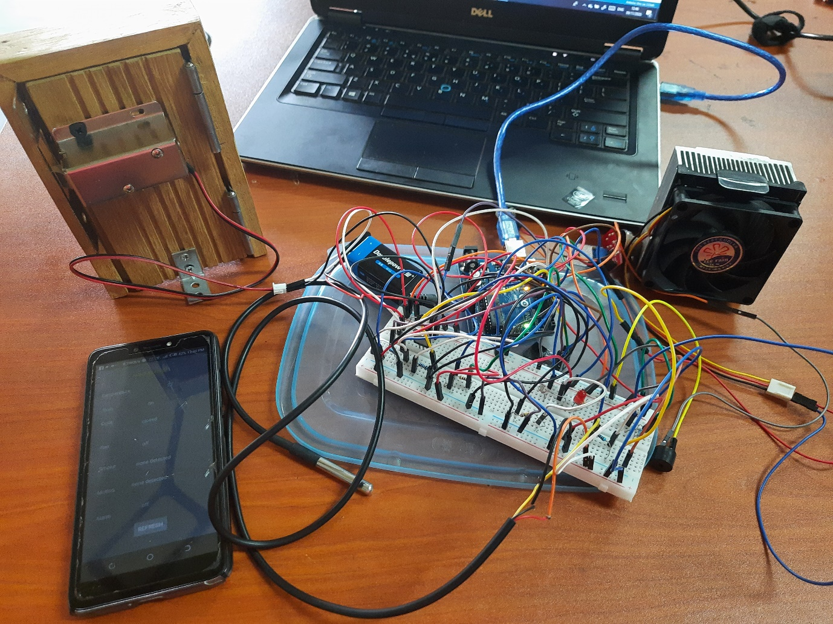

Figure 8.1 Smart Home System

This is the smart home system. There are sensors, home appliances and the mobile application.

**SMART HOME MOBILE APPLICATION**

### LOGIN SCREEN

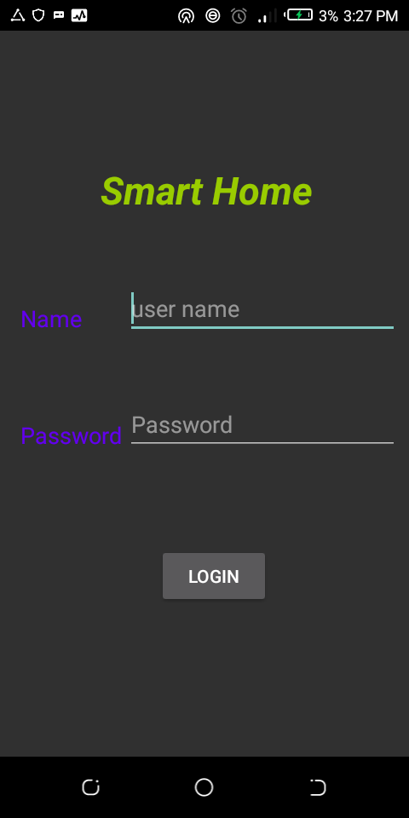

Figure 8.2 Login Screen

This is the login screen which allows the users to access the system. The user has to enter their usernames and passwords and click on the login button.

### CONTROLS SCREEN

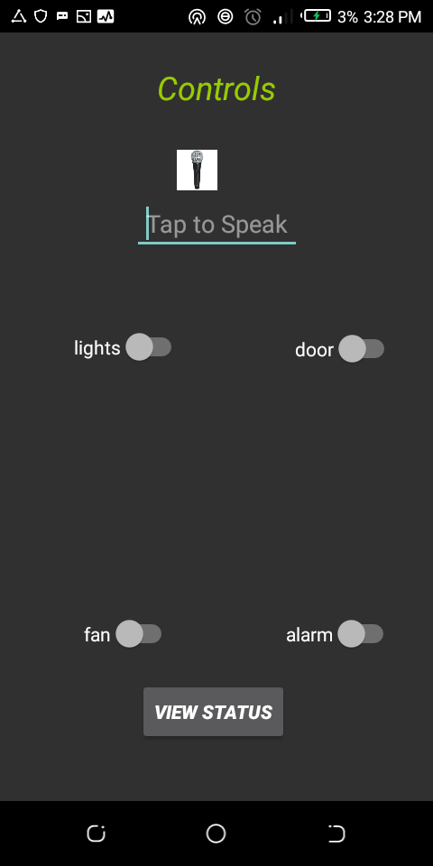

Figure 8.3 Control Screen

This is the controls screen which allows the users to control the home appliances either by voice recognition or by clicking the buttons for turning on or off. The users have to click on the view status button if they want to view the status of the home appliances.

### STATUS SCREEN

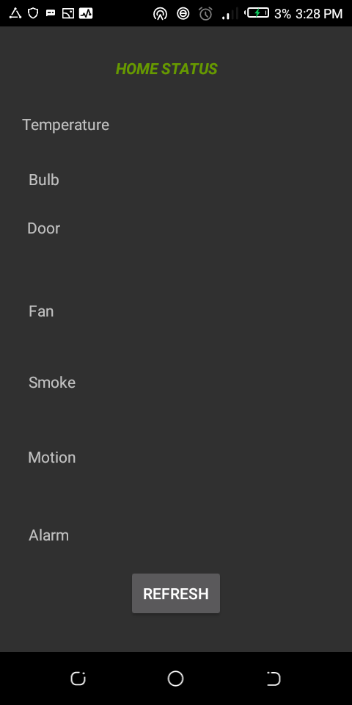

Figure 8.4 Status Screen

This is the status screen which allows user to view the status of the home appliances so that they can know what is going on in the house. And the users can also click on the refresh button to refresh the status of the appliances.

| **Final approval for use** | | |
| --- | --- | --- |
| Identification: | |  |
| Responsible for validation: | |  |
| Remarks: | | |
| Date: | Signature: | |